Host range
Various microorganisms in which a plasmid can replicate and be maintained is called its host range. Accordingly, plasmids can be classified into narrow and broad host ranges. Broad host range plasmids are of considerable interest because they not only play an important role in horizontal gene transfer but also their replicons can serve as good sources for vector construction.
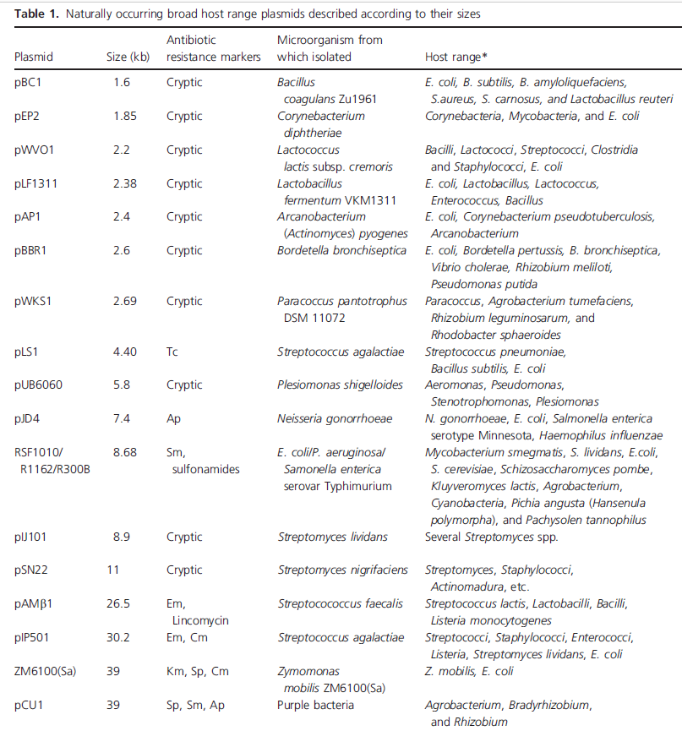
Factors affecting broad host range (BHR) plasmid replication
- Presence of multiple origins
Some plasmids have multiple origins and one origin functions in one type of host and the others are functional in other hosts. Examples of such plasmids are pJD4 (IncW) and pCU1 (IncN). The BHR plasmid pJD4 (7.4 kb) isolated from Neisseria gonorrhoeae was found to contain three clustered but distinguishable origins of replication, namely ori1, ori2, ori3, and two genes for replication initiation proteins, RepB and RepA, necessary for the functioning of ori2 or ori3 and ori1, respectively.
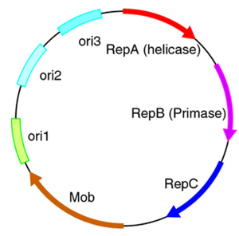
Figure: Idealized depiction of a broad host range plasmid originating from a Gram-negative bacterium. The genes repA, repB, and repC encode for the helicase, primase and initiator protein.
- Structure of origin
The structure of the origin also plays an important role in governing the host range. The best example is plasmid RK2. They have the ability to transfer between and replicate in nearly all species of the Alpha-, Beta- and Gamma proteobacteria. Broad host range plasmid RK2 (60 kb) consists of a replication origin (oriV) and a TrfA (trans-acting replication function)-encoding gene. The minimal origin (oriV) possesses five iterons and is functional in E. coli. However, the presence of three additional iterons stabilizes RK2 maintenance in Pseudomonas putida. In addition, the region with four DnaA boxes is essential for RK2 replication in E. coli, but is dispensable for replication of the plasmid in P. aeruginosa. This suggests that structural elements of origin are employed for BHR plasmid replication and maintenance in different bacterial hosts.

- Replication initiation independent of host initiation factors
Plasmids that do not require host proteins for replication can maintain themselves in many different bacteria. For example, the IncQ plasmids have a broader host range than any other known replicating element in bacteria. The features responsible for this are as follows: initiation of replication, involving DnaA-independent activation of the origin, and a dedicated primase, which is strictly host independent.These plasmids are usually nonconjugative but are mobilizable by a variety of type IV transporters. Moreover, they have high copy number and exhibit reduced metabolic load.

